PHASE 7: Project Documentation Phase
Project Team Members
M.G Misriyathul Ibrahima
S.M.B.N Meera Jenira
V.Mohana
P.Mutharasi
S.A.K. Muthu Ameena

Project: Implement Client Script & UI Policy (Incident)
ServiceNow – Incident Management

Phase Objective
To record the project implementation, configuration values, scripts, testing procedures, evidence, and final outcome in a reproducible format.

Documentation Structure
- Project problem statement and objective.
- Skills and ServiceNow components used.
- UI Policy configuration.
- UI Policy Action configuration.
- onChange, onSubmit, and onCellEdit Client Scripts.
- Testing activities and expected results.
- Screenshot evidence from the implementation recording.
- Final outcome and conclusion.

Configuration Record
UI Policy: High Impact Control; Table: Incident; Condition: Impact is 1 – High; Reverse if false: enabled. Client Script types: onChange, onSubmit, and onCellEdit.

Evidence Record
The documentation uses screenshots extracted from the uploaded project recording. Captions identify what is visible in each screenshot rather than assuming information that is not visible.

Maintenance Reference
The documented configuration can be used as a reference when reviewing, demonstrating, or troubleshooting the Incident client-side controls.

Project Evidence – Screenshots
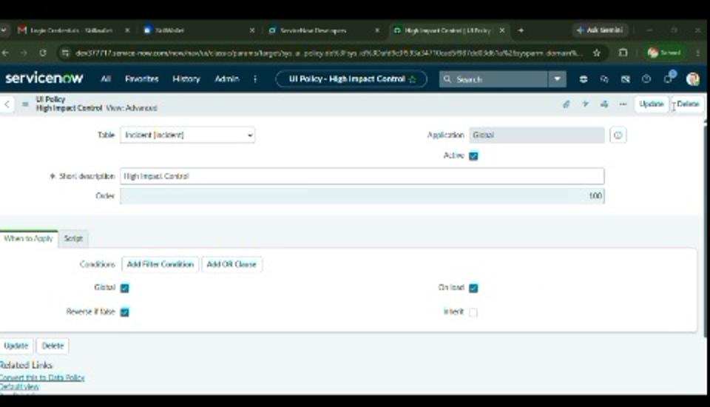
Figure 15. Configuration evidence recorded from the ServiceNow implementation.
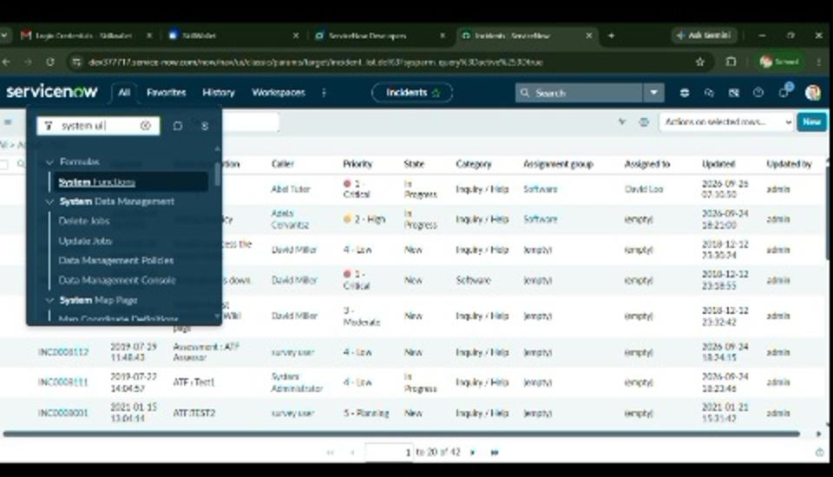
Figure 16. Incident list evidence used in the project record.

Phase Outcome
The implementation details, configuration values, scripts, testing procedures, and screenshot evidence were organized into project documentation.

